**Dashboard:**

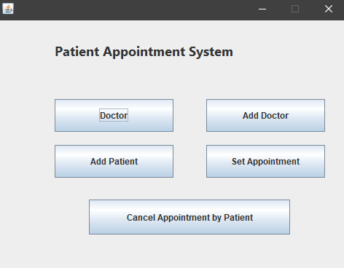

**Login Screen:**

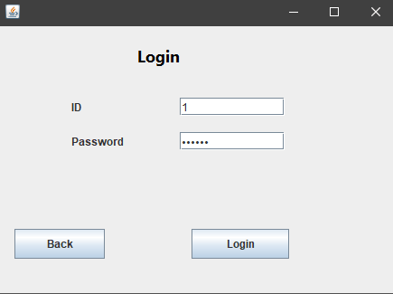

**Doctor Screen:**

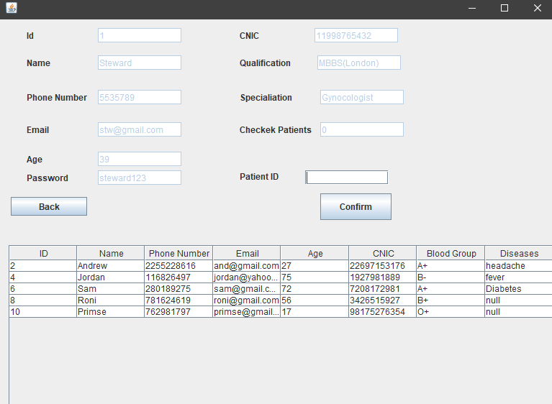

**Check Patient:**

After writing patient ID, you can check patient details and prescribe medicines and tell the diseases. Moreover, you can also Cancel Appointment by clicking on Cancel Appointment button:

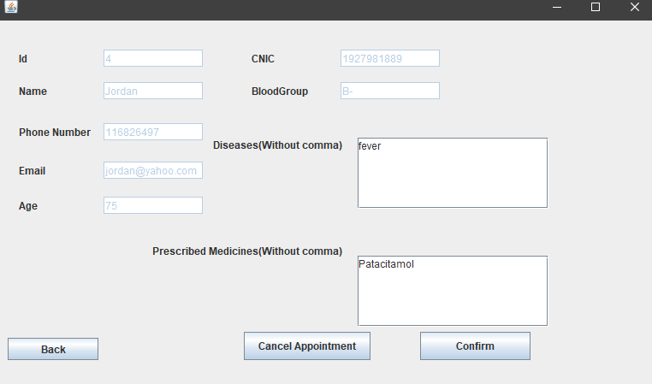

**Add Doctor:**

* **Admin:**

For adding a doctor, you must have to write admin details (which is by default Username: abc and Password: abc). Screenshot is given below:

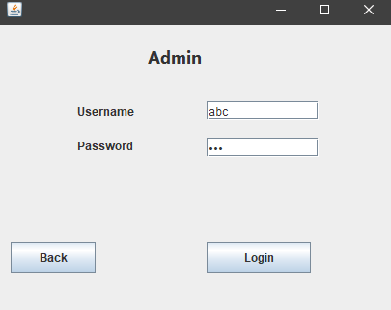

* **Add Doctor Screen:**

After adding admin details you can add doctor by entering following information, system is generating default Doctor ID which must be an Odd Number:

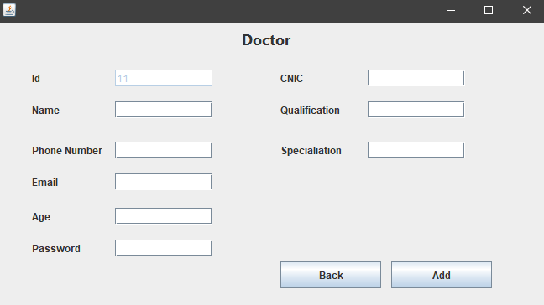

**Add Patient:**

* **Addpatient Screen**

Person can add himself/herself by entering following information, system is generating default Patient ID which must be an Even Number:

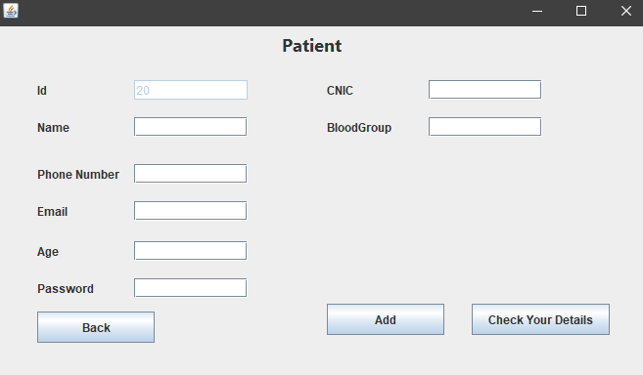

* **Check Your Details:**

After clicking on check your details, you will go to a user Screen and after adding ID and password you will see your details. Otherwise it will show you an incorrect data message.

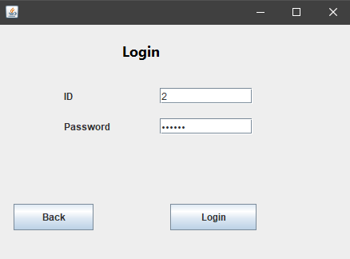

**After Entering Details:**

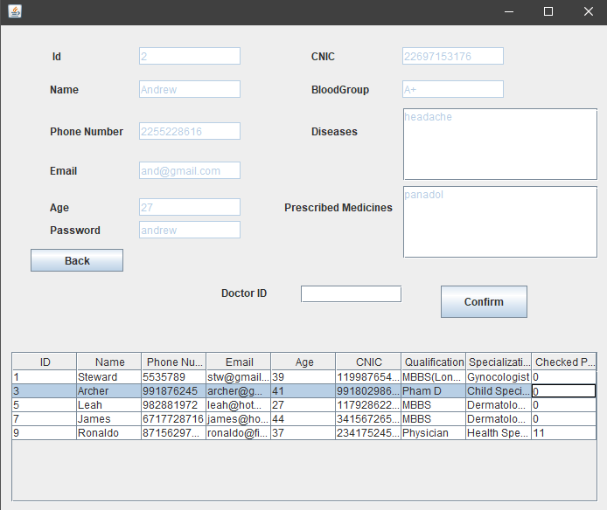

You can also set appointment from this page. We can also see another procedure later.

**Set Appointment:**

* **Login:**

For setting appointment, you must have to login your patient account and then write a Doctor ID to register your appointment. As screenshot is given below:

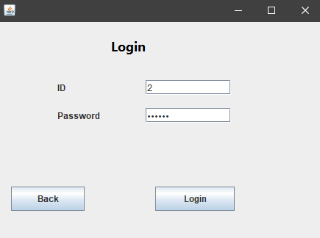

* **Register Appointment:**

After login, you can see your information and also you can set your appointment.

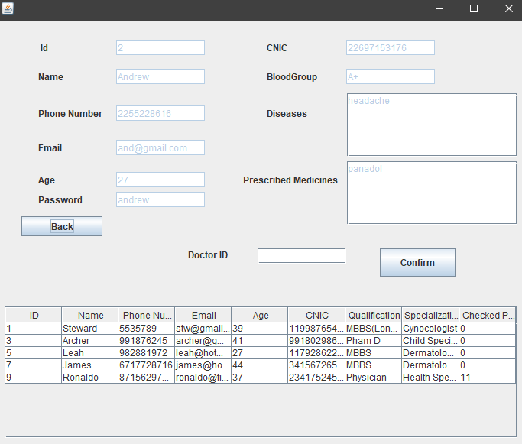

After entering any doctor id, you will see a confirmation message:

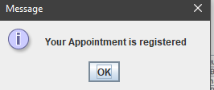

**Cancel Appointment by Patient:**

* **Entering ID and password:**

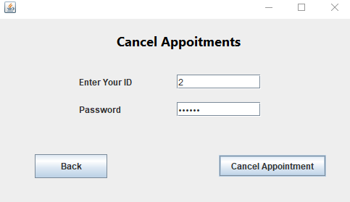

* **Confirmation Message:**

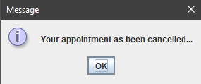

* **Error in Writing Wrong information:**

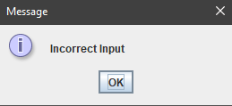

* **Don’t have any Appointment:**

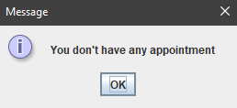

**Some Common Incorrect Information Errors:**

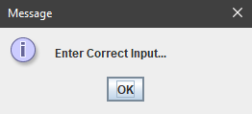

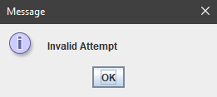

**Etc.**